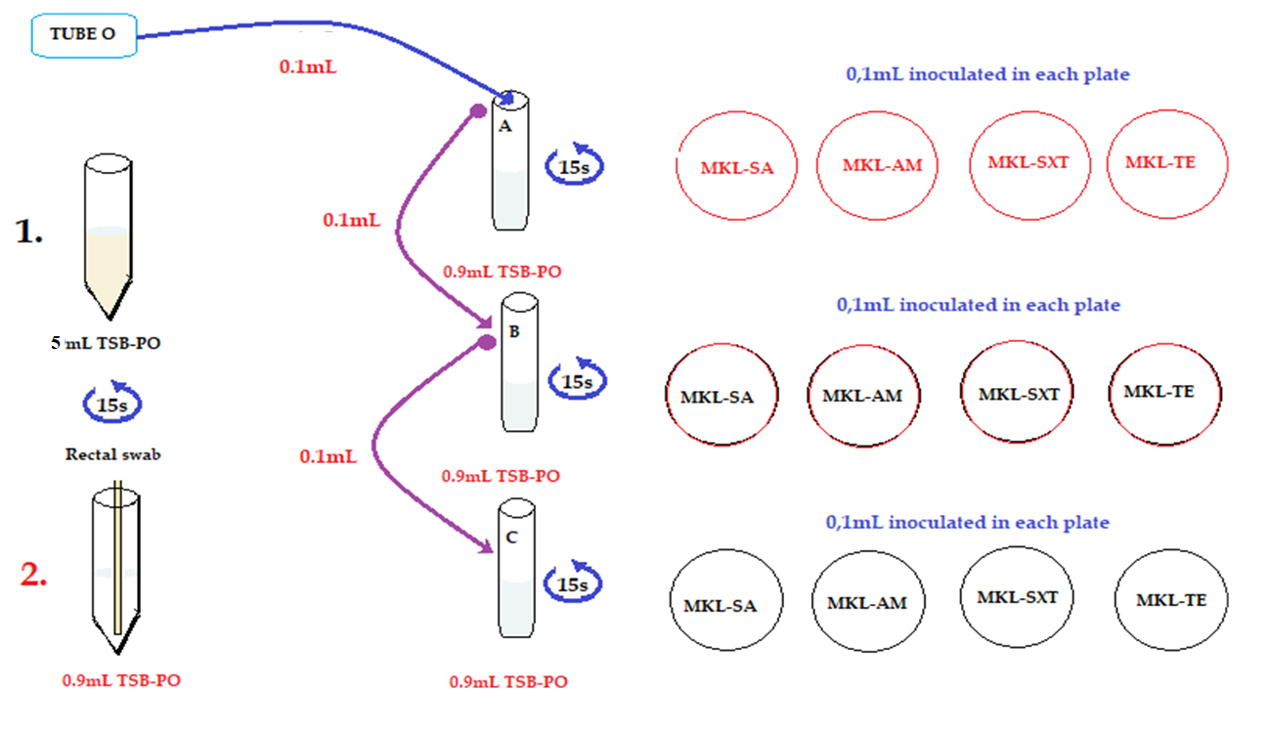
S3.1 Laboratory protocol for microbiologic analysis from rectal swab sample taken from pigs. Each swab was diluted in TSB-PO (Tryptic soy broth in phosphate saline buffer). 0.1mL of each corresponding dilution was plated in Mac Conkey Lactosa agar (MKL) without antimicrobial supplements (SA), or with ampicillin (AM), Trimethoprim - sulfamethoxazole (SXT) or Tetracycline (TET). All tubes were mixed 15 seconds in vortex before taking the aliquot to be inoculated in the plate. Tube “O” is the initial elution, then A, B and C are the corresponding ten-fold serial dilutions.

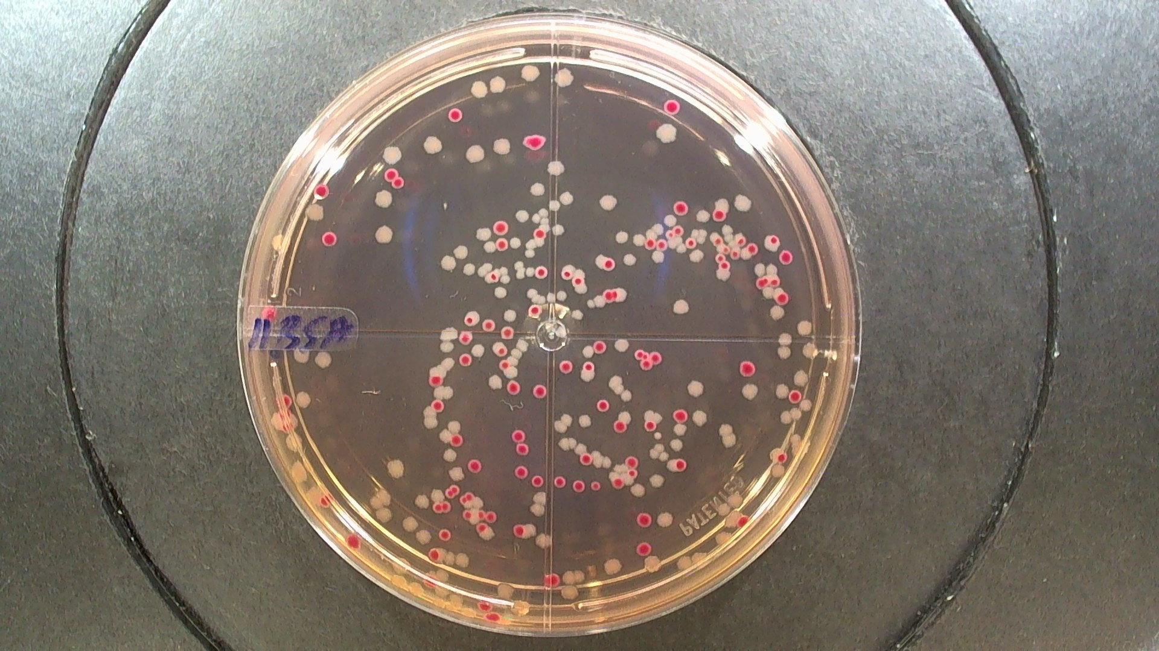
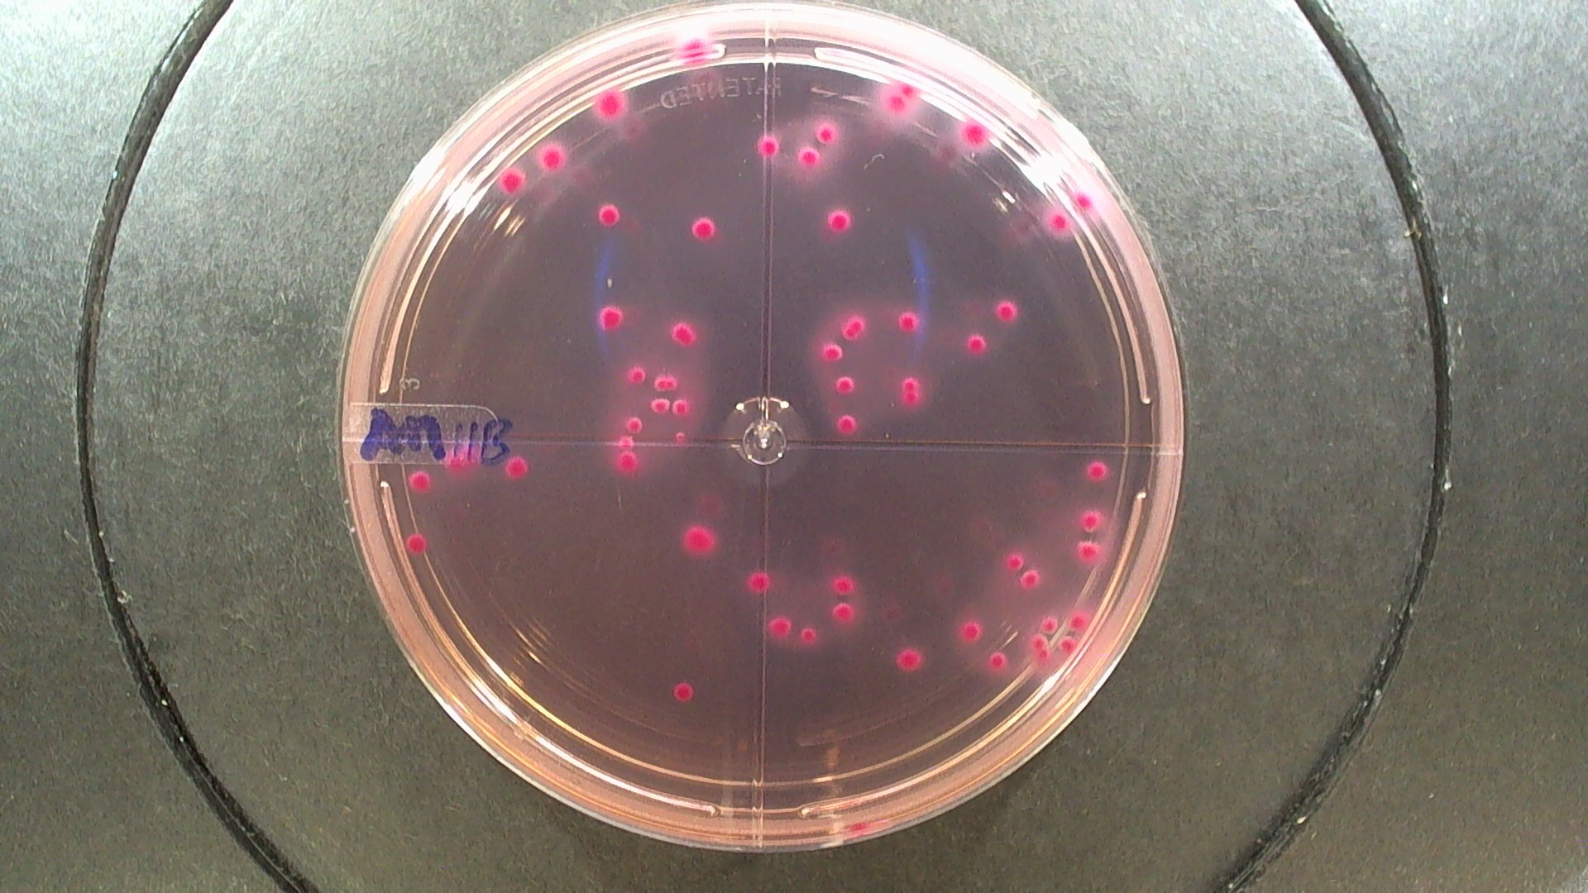
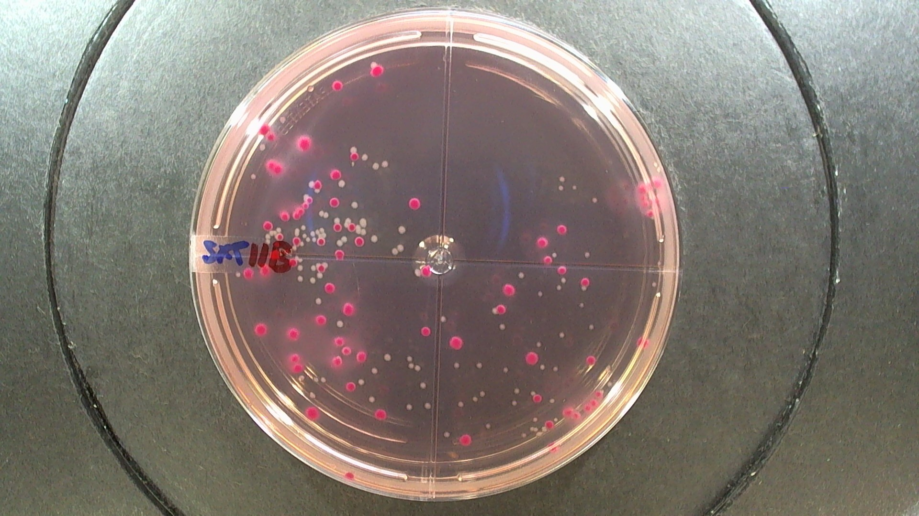
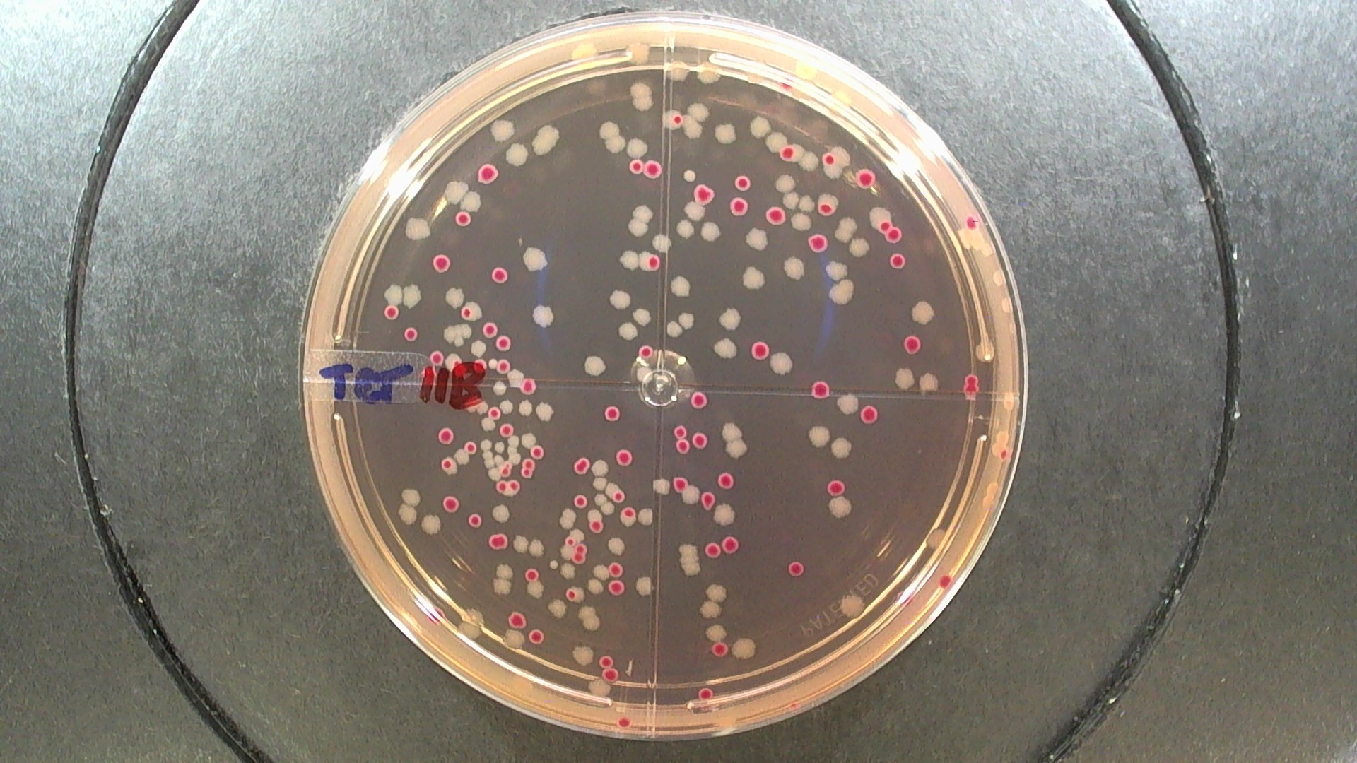

S3.2 Images of bacterial growth after 24 hours at 35°C of incubation. Since left to right Mac Conkey Lactosa plates: without antimicrobial supplements, with ampicillin, with trimethoprim sulfamethoxazole; tetracycline. It is possible to see separated colonies. Only Lac positive ones were counted and registered. Plates with less than 4 colonies were discarded.

